HW Trigger using 6843 Radar

# Hardware Requirements

1. [DCA1000EVM](https://www.ti.com/tool/DCA1000EVM) with modifications
2. xWR1642BOOST
3. Microcontroller to send HW trigger pulses

# Software Requirements

1. [TI mmWave SDK 3.5.0.4](https://www.ti.com/tool/MMWAVE-SDK)
2. [TI Uniflash](https://www.ti.com/tool/UNIFLASH)
3. [TI mmWave Studio 2.1.1.0](https://software-dl.ti.com/ra-processors/esd/MMWAVE-STUDIO/latest/index_FDS.html)
4. Josiah’s single or dual radar GUI
   1. Requires MATLAB

# Hardware Set Up

1. DCA1000EVM
   1. Remove R120
      1. Suggested [here](https://e2e.ti.com/support/sensors-group/sensors/f/sensors-forum/710632/awr1243-dca1000-and-1243-hardware-trigger-sts_no_lvds_data)
   2. Connect to the xWR1642Boost with 60 pin connector as shown on page 16 [here](https://www.ti.com/lit/ug/spruij4a/spruij4a.pdf?ts=1620662137280&ref_url=https%253A%252F%252Fwww.ti.com%252Ftool%252FDCA1000EVM)
   3. Connect to the PC over USB on the RADAR_FTDI/J1 connector and over Ethernet
   4. Connect 5V/3A power
2. xWR1642Boost
   1. Connect to microcontroller (MCU)
      1. From [Josiah’s E2E post](https://e2e.ti.com/support/sensors-group/sensors/f/sensors-forum/998616/iwr6843isk-custom-binary-for-cli-lvds-hw-trigger/3692785?tisearch=e2e-sitesearch&keymatch=%20user%3A448661#3692785):
         1. For IWR1642Boost, on page 10 of PROC049B(002)_Sch.pdf, AR_SYNC_IN is pin 9 of J6 **(IMPORTANT)**
         2. For AWR1642Boost, On page 10 of PROC011C(002)_Sch.pdf, AR_SYNC_IN is pin 9 of J6 **(IMPORTANT)**
         3. For newest revisions, the R165 resistor is already shorted, enabling the HW trigger input
         4. Ground is pin 4 of J6 or pin 2 of J5
   2. Connect to the PC over USB
   3. Connect 5V/3A power

# Software Set Up

1. Flash the SDK demo to the xWR1642Boost (See [SDK 3.5.0.4 User Guide](http://software-dl.ti.com/ra-processors/esd/MMWAVE-SDK/latest/exports/mmwave_sdk_user_guide.pdf) section 4.2)
   1. Set the device to Flash Programming Mode by bridging SOP0 and SOP2. Similar bridging is shown on the MMWAVEICBOOST in step 5 [here](https://dev.ti.com/tirex/explore/content/mmwave_industrial_toolbox_4_7_0/labs/common/docs/hardware_setup/hw_setup_mmwaveicboost_mode_flashing.html) and below

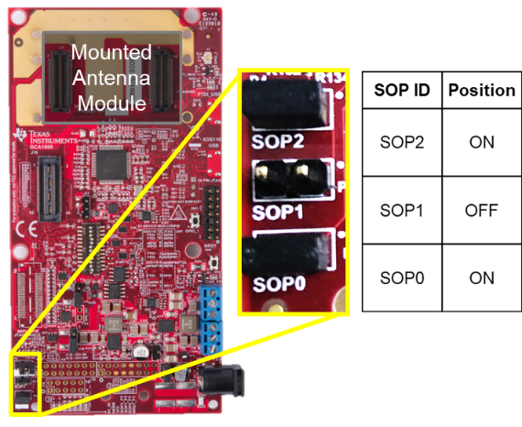

* 1. Power cycle the xWR1642Boost
  2. Once the device is properly connected to the PC, download the demo firmware using Unifash
     1. Typically under the path: “C:\ti\mmwave_sdk_03_05_00_04\packages\ti\demo\xwr16xx\mmw”
  3. Once the download is complete, set the device to Functional Mode by bridging only SOP0 and remove the bridge on SOP2
  4. Power cycle the xWR1642Boost

1. Setup the DCA1000EVM on the proper IP address (See the [DCA1000VEM Quick Start Guide](https://software-dl.ti.com/ra-processors/esd/MMWAVE-STUDIO/latest/exports/DCA1000_Quick_Start_Guide.pdf))
   1. Once the device is properly connected to the PC, open the start menu and search “View Network Connections”

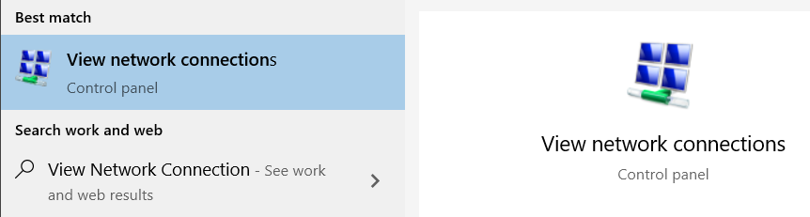

* 1. Inside the “Network Connections” of Control Panel, right click on the Ethernet port of choice and select “Properties”
  2. “Local Area Connection Properties” window will open. Right click on “Internet Protocol Version 4 (TCP/IPv4)”.
  3. “Internet Protocol Version 4 (TCP/IPc4)” window will open. Set the IP address field to 192.168.33.30, or the desired IP address if different
     1. See our other documentation on changing the IP address of the DCA1000EVM using the DCA1000 CLI Utility (necessary for a dual radar setup)
  4. The Subnet mask field can remain the default 255.255.255.0
  5. Press “OK” on all the windows and you can close “Network Connections”

1. Open the Josiah’s single/dual radar GUI
   1. Under the “dual-radar-gui” repository, open “single_radar_gui.mlapp” or “dual_radar_gui.mlapp.”
   2. App Designer window will open to the app of your choice in the previous step
   3. Press “Run” at the top of the page
   4. The app will open and all the indicators will be red
      1. Assuming you have installed mmWave Studio 2.1.1.0 to the typical location, it will open normally. Otherwise, it will ask you to find the installation location of mmWave Studio 2.1.1.0
   5. Ensure the Start Freq (GHz) field is 77 GHz
   6. Press “Connect Radar 1”
   7. A window will appear asking to select a serial COM port. Select the COM port corresponding to the entry in device manager labeled “XDS110 Class Application/User UART”.
   8. Press “Prepare DCA 1”
   9. Enter the desired chirp parameters
   10. Press “Configure Radar”
   11. Press “Start” to start the capture
       1. The DCA1000EVM will start waiting for data over LVDS
       2. The xWR1642Boost will wait for HW trigger from MCU
          1. If everything is working properly at this point, the DS3 LED on the xWR1642Boost will be turn on
   12. Start the MCU sending pulses
       1. If everything is working properly the DATA_TRAIN_PRG LED on the DCA1000EVM will be flashing while the radar is triggered
   13. Press “Stop” to stop the radar once you are done